**Document for Orientated Phase of Martin Petkov**

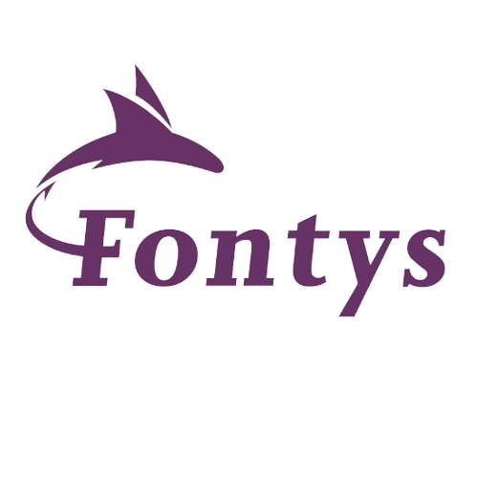

EINDHOVEN 2024, R 10

P-CB-M-CMK, Semester 1 Media Phase

**Fontys University of Applied Sciences, Eindhoven R10**

This document is meant to document my journey through the orientation phase and will be adjusted according to feedback. The **document is structured in () parts including: Website Section, Group Section, Professional and Technical skills.**

Add the content table

# *Introduction: A short interview feat. Myself:*

**About you:** - My name’s Martin 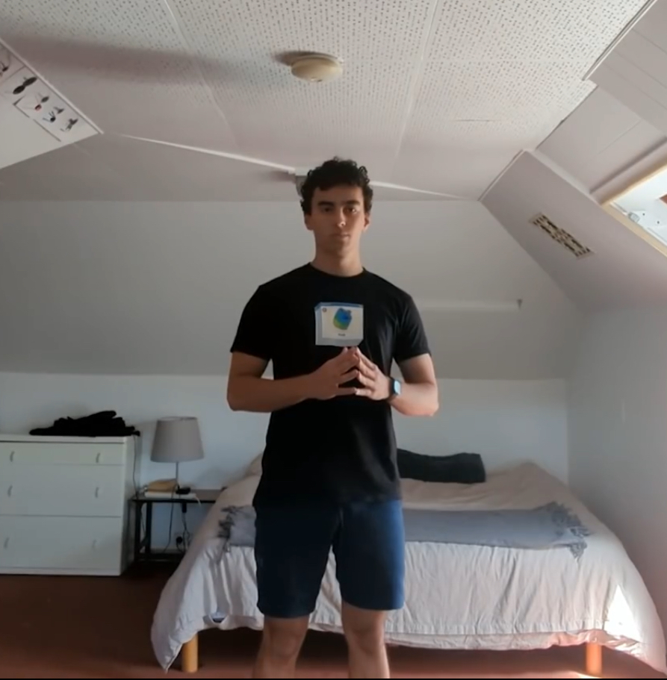as you already know I’m a Fontys ICT student. I’m 19 years old, hailing from Eastern Europe, Sofia, Bulgaria. My hobbies are art, photography, music overall visually and early pleasing stuff.

**Why did you choose Media:** - I chose media because I find the mixture of creativity and technology essential for me to succeed in the direction I’m aiming. I find technology to be an integral part of Media Design and an interesting proposition to today’s art landscape and so even if I’m not the biggest fan of coding I’m interested to learn web development and continue improving myself in both directions so I can realize my ideas.

**Any future plans:** - Something I love to do, something that I can sprout in, creatively, not certain of it, and that’s why I like Media so much, because of the proposition that I can pick up anything in this sphere.

# **Personal Website – Wireframes, Development, Feedback, Reflection, Decisions**

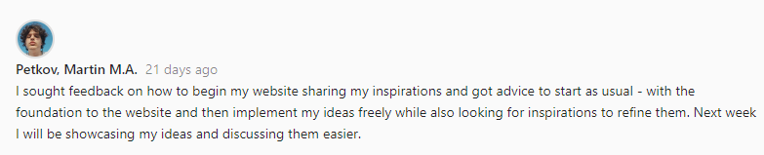

Wireframes

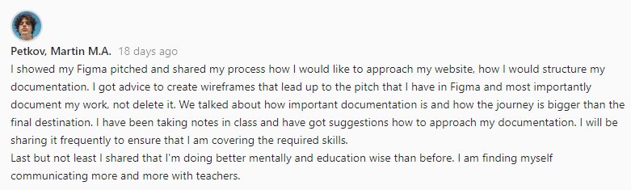

Pitches

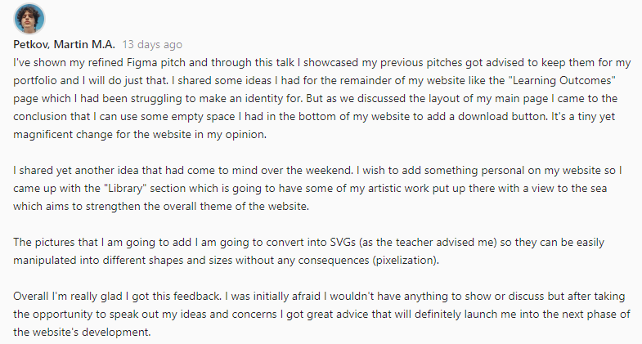

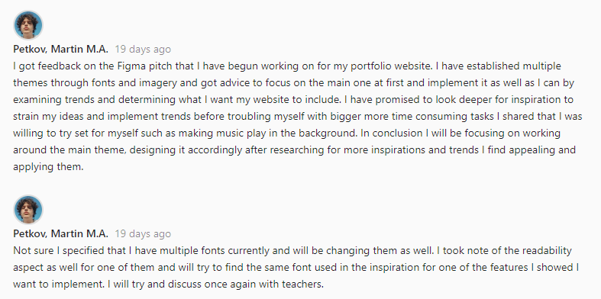

Feedback

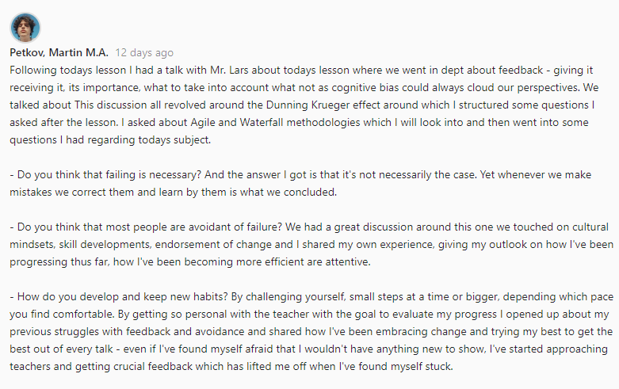

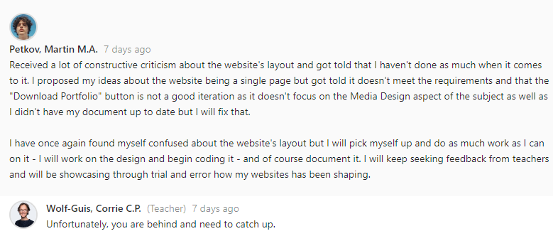

Give an inside to where I got stuck how I unstuck myself and where I am currently (setting myself up for what’s to come)

Group Project Section – My Contribution, Feedback, Reflection, Decisions

This part of my Documentation is meant to showcase my contribution to the group project.

One of our first lessons required us to create groups and discuss the subject. We brainstormed… … . Another thing we had to do is create a poster for our project to “sell the idea” in front of the class. In our research we got to know about the Gestalt method:

**GESTALT** – **“Psychological approach to “how humans gain perceptions“ = How do we process what we see and organize our thoughts. Originally not a graphic design approach – but quickly adapted by the industry - Essential part of visual design.”**

**Another definition is - an organized whole that is perceived as more than the sum of its parts.**



And so by dividing parts for the poster I made the logo

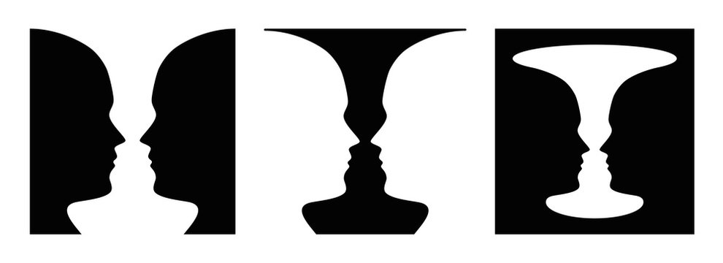

Example I found which I used as inspiration to create the logo for our poster

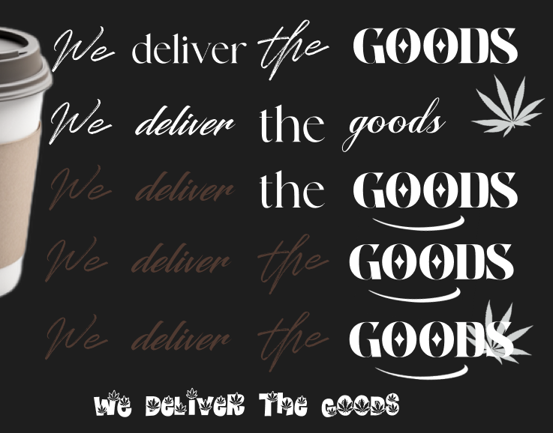

Different logo iterations



**From the presentation itself I got advice to fix the “D” as it was hardly recognizable from distance, and it had been mistaken for an “N”. Regardless I got positive feedback on the logo itself as most people saw the eyes and face which was the goal.**



This is the version after feedback – fixed color to match the rest of the text as well as made it more readable

Slideshow:

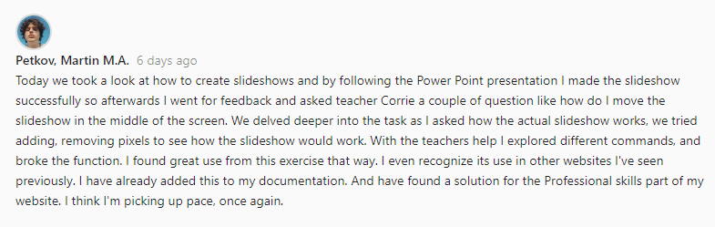

Pokemon Card:

Cat Rescue Website:

# Professional skills:

Establishing the foundation has to be one of the most important and time saving steps to consider when starting off with a project (or subject) that’s why I’m listing what we’re going be focusing on this part of 1st semester – User research, Prototyping, HTML + CSS.

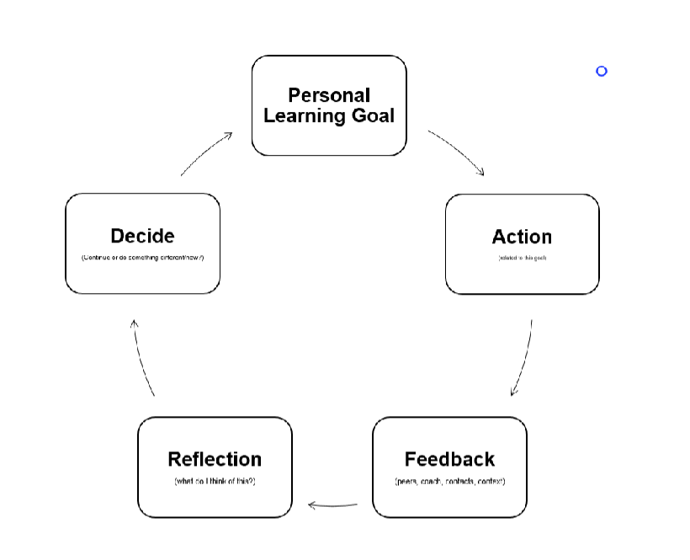

How I aim to go through the profile phase

**First week we went through the establishment of Gestalt method and did a poster for our group’s project which was a group effort each one of us took part in. After coming up with the idea for the website itself.**

Technical Skills

**Quick quiz:**

* **What Sitemap do people use to navigate your website?**
* **Where does a grid start with position 0,0?**
* **How do you combine two grid elements vertically?**
* **Flex: What is the difference between space-around and space-between?**

**Creating a slideshow using the assistance of a PowerPoint**

**Notes to be added in.**

**Comparative analysis**

Starting off with wireframes

* Functionality and color in the low level fo the prototype is not recommended
* Color in the first wireframe is wrong because it takes focus from making the structure
* 1st wireframe is about the composition and balance
* 60 30 10 rule – start out with the main color and the contrast color (often being black or dark red), the 30 percent is what we want the user to observe. It’s important because it helps balance out the layout. Color can fake balance or waver it. If balance already works without colors

Week 11 e twa gore

Week 12

Week 13

Trqq da go naprawq

Week 1 ne e etolkowa mngoo stegni se

**Learning Outcomes Page:**

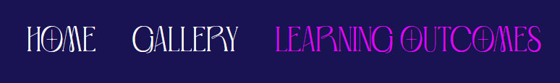

I stared the development of the Learning Outcomes after the whole class got (U) undefined on professional skills, because of the lack of documentation on the website. That’s why I started working on that page shortly after I figured out the problem with the custom background on the main page.

I started off as usual – I researched websites with a familiar theme.

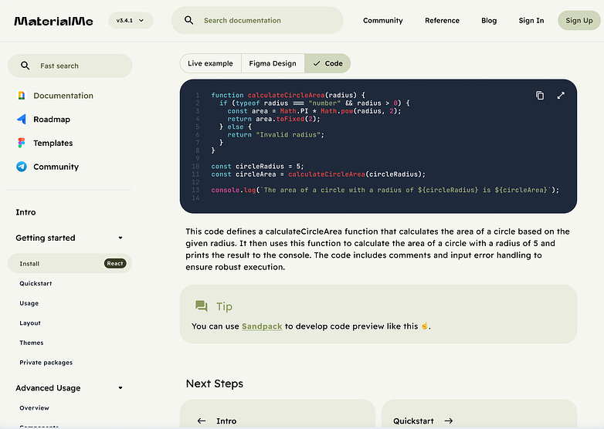

Found this W3 lookalike on Dribbble

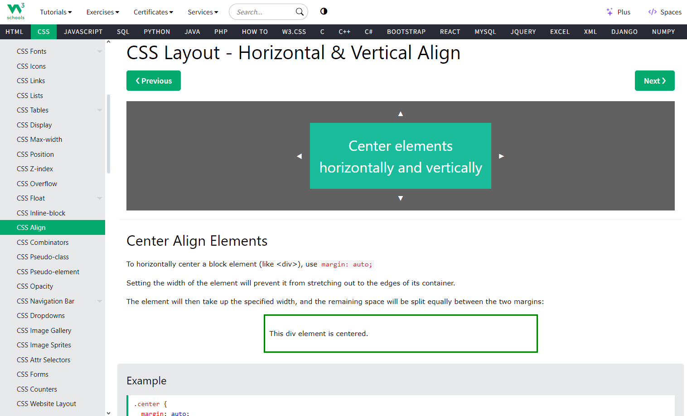

By examining It’s clear that this website pitch and W3 have a lot in common in the way that bnoth websites make use of the sideways nav bar and the way that they style images and text.

Upon retraction (making the window smaller) I notice how the main nav bar stays unchanged, it just shrinks, yet the sideways menu moves into a burger menu. I find this as a clever way to make usability for people from smaller devices, one that I will try to implement later on.

Another website that had the same way of approaching smaller screens is this apple product design page – another document type of webpage.

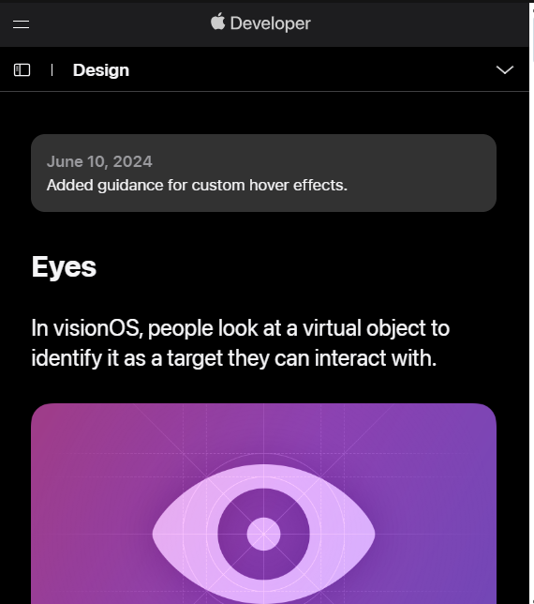

The page folds up, keeping the same layout, with a burger menu appearing. What’s different for this webpage however is the way the burger menu works here. Upon opening it drops from the top, down, showcasing the original nav bar that the user can see on top. I figure this is the case because the page is set in such a way that the user can scroll through and read everything in order and so they would only need the main menu, which I find to be a decent approach on the interactivity aspect, because it compliments in the overall theme of the website.

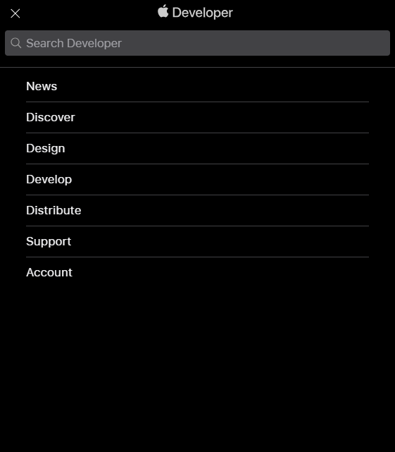

I took great interest in the clean, smooth and interesting design of the website and took a further look.

I made a pitch of how I imagined my webpage based on the research:

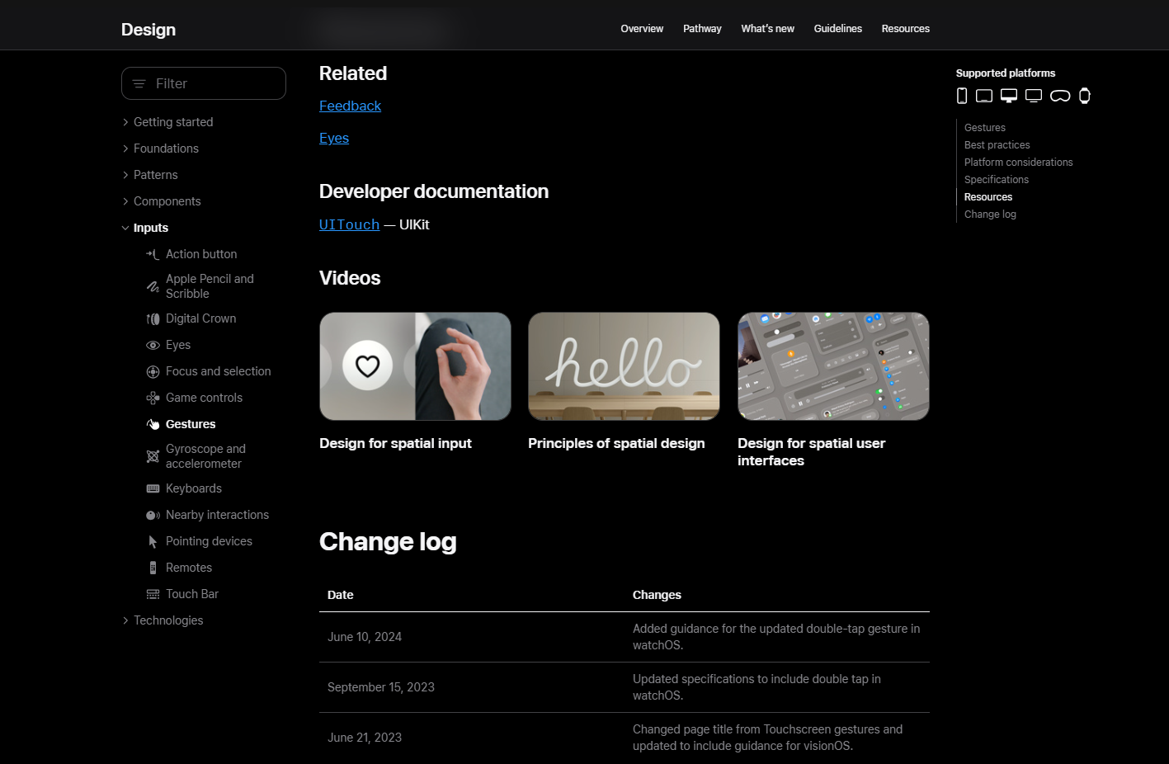

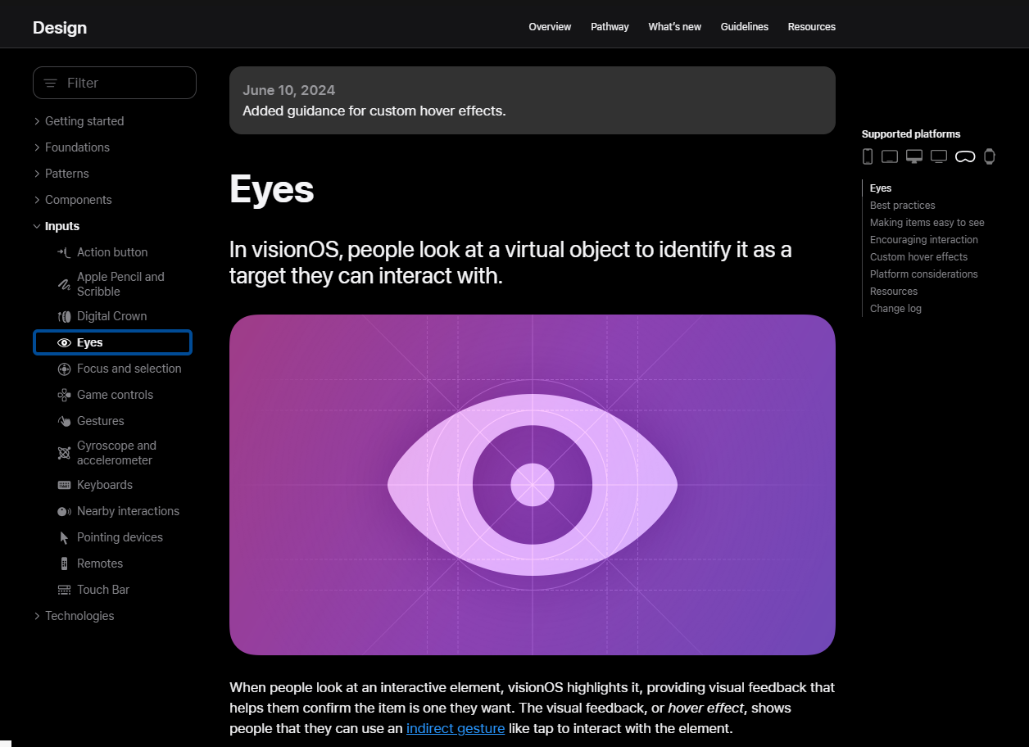

Link: <https://developer.apple.com/design/human-interface-guidelines/eyes>

I

Through observation I’ve noticed how each website that has a Documentation type of page/layout has a sideways menu for navigation through the menu, which I find really useful and appealing for the website’s design.

Another simple yet really attractive feature of the websites I looked through is the styling of images, text, links, highlights and etc. I wish to create a simple, clean, easy to navigate page with a side menu which has links to each outcome and sends the user to that part of the page, whenever interacted with.

Development:

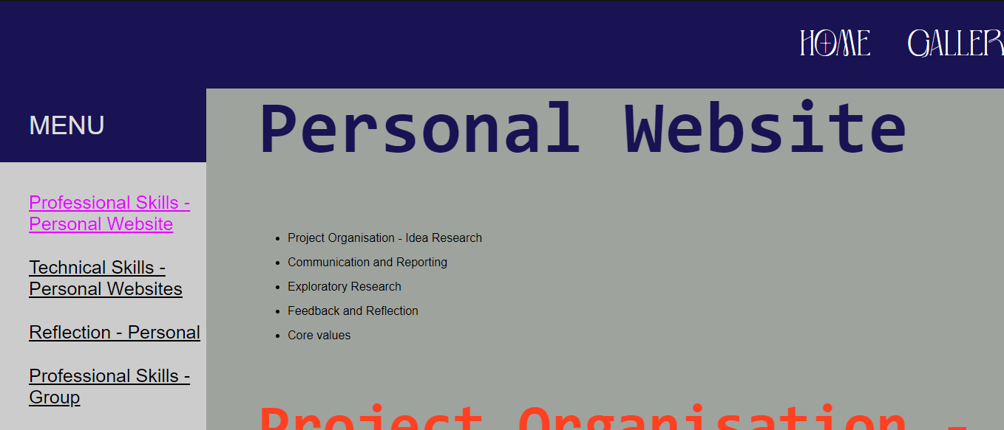

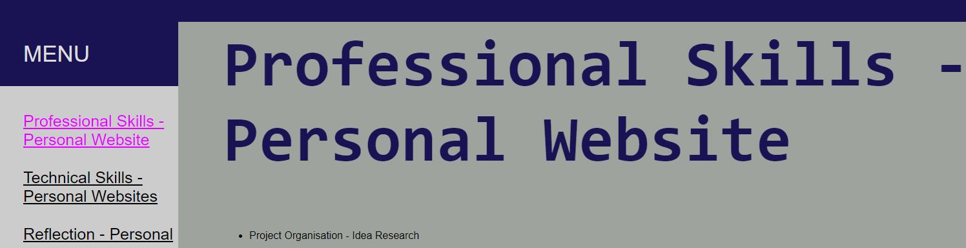

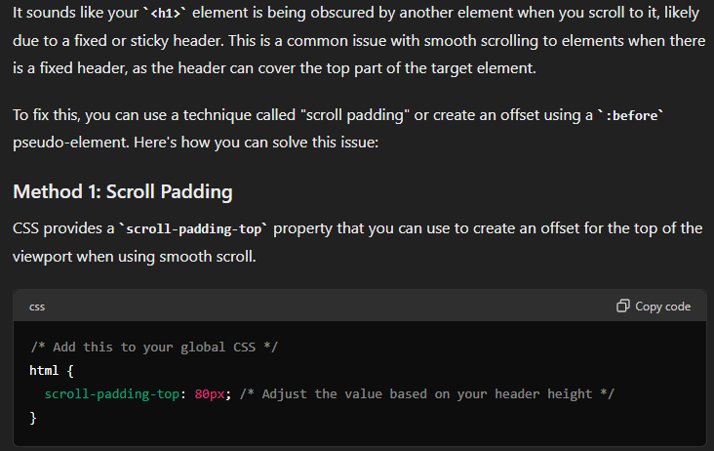

This fixed a problem I had with the <li> to <code> response. I would scroll to the <li> and would showcase only half of the text, I found that I didn’t have enough control over my smooth scroll and so I added scroll padding top: - adjusted it to the needed size.

To recreate the sideways menu my webpage required I looked for

Learning Outcomes page development:

Yesterday I showed my webpage, the Learning Outcomes page in particular. I shared with the teacher that I had done research on documentation type websites, and that I had found some code about a menu I really wanted to include in my code. At that time I had just finished with the layout, which was code from somewhere else that I had adjusted to my own standarts.

But yet, because my code was a mess I got warned that I haven’t proven my technical skills and because I hadn’t documented my problems with the inclusion of the CSS of the sideways menu, I hadn’t proven my Technical skills.

Just adding randomly

* Home



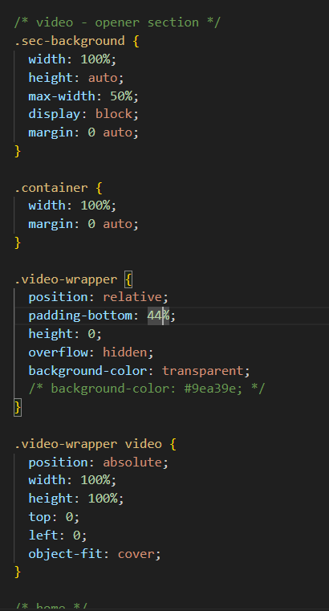

Adjusting video properly and trying background: transparent to remove any outlines there may be.

* Recently I got feedback about the text on the Learning Outcomes page, how it was too small and the colors were not fitting which, after thinking through I agreed on and that’s why I was trying to fix it. I centered the text, increased its size, and adjusted the width and height to ensure it displayed smoothly from left to right, making it easier to read according to the research I did after the feedback I was given.

I tried a couple of different approaches like justify-content: center; with flexbox but I didn’t like how it looked as the margin was too little and was getting overwritten and so It felt like I didn’t have much control so I went with adjusting it by px’s. Set padding: 0px;

With this document type webpage, I’ve showcased my ability to adjust margins and paddings properly, having control over the layout, implementing changes as needed.

I did research for the coloring for the readability of the webpage as it is in a document form. Previously having a class about user accessibility I looked at this website for a better [understanding on formatting my webpage](https://ux.stackexchange.com/questions/132460/do-some-technical-documentation-) as well as [the introduction of European accessibility law](https://ec.europa.eu/social/main.jsp?catId=1202&intPageId=5581&langId=en). I’ve made changes according to these sources in the process I’ve made the webpage way more appealing and easily readable. I sought feedback from fellow colleagues and they also agreed that these changes were needed.

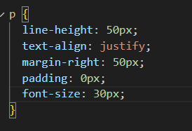 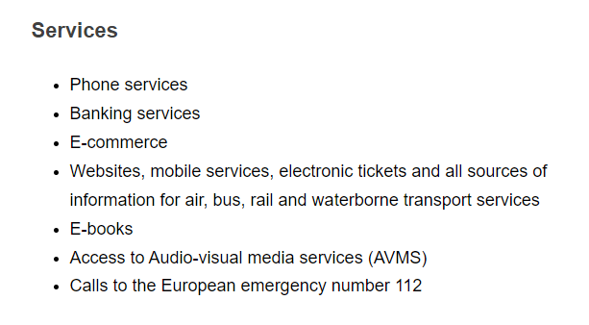

* Finally to ensure that I’ve applied the newly gained knowledge about acessability of my website I checked the colors I am using for my website:

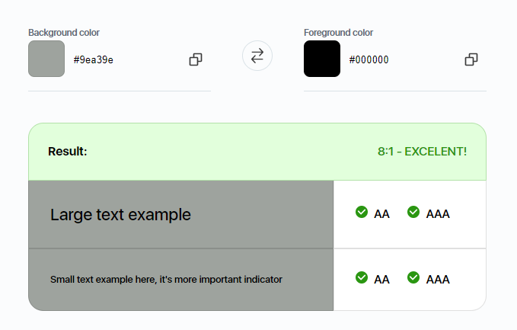 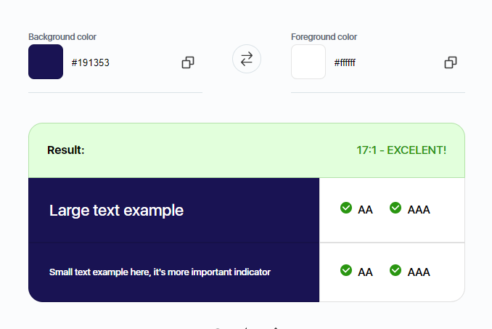

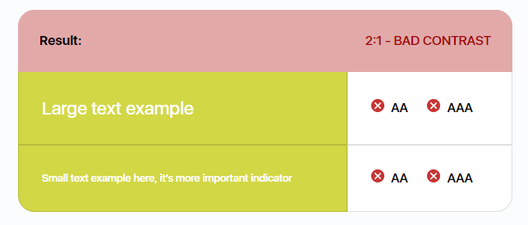

*Before :*

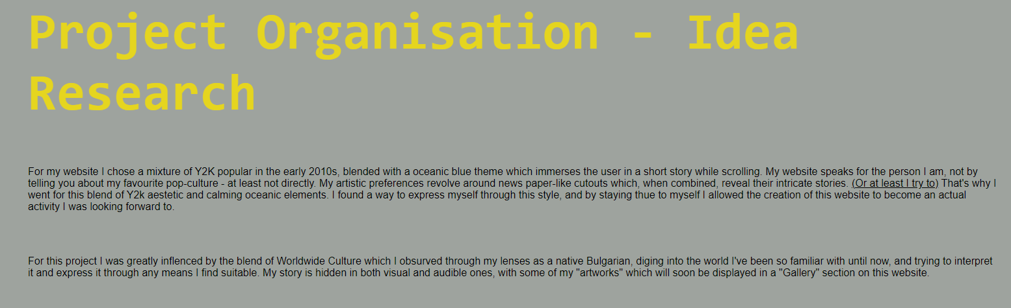

*After:* 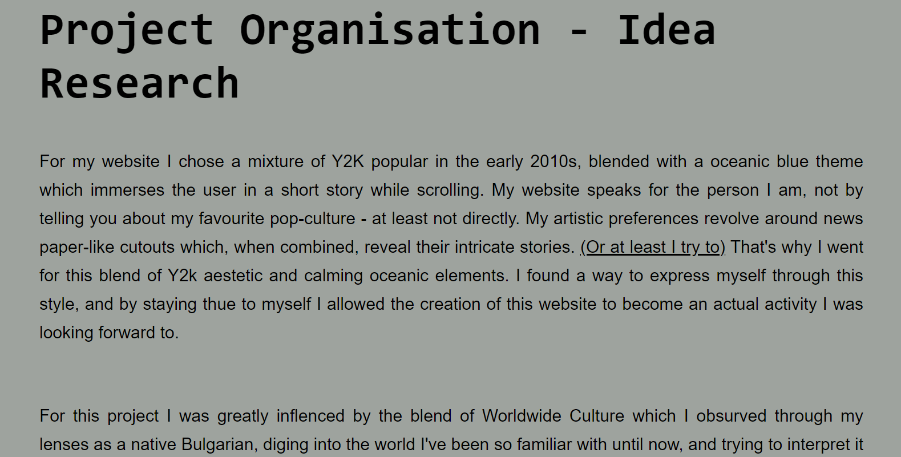

*The changes that I made:*

* Made the text bigger.
* Added more space between lines.
* Adjusted margin so the text centers.
* adjusted text to wrap as “justified” – like the format in Word.
* Changed color of the header for clarity and readability.
* Sought feedback on this change and got positive reactions.

*Changes to be made:*

* Make the layout of learning outcomes page cleaner ( as currently its not as clear)
* Look over the learning outcomes once more
* Add as much of them as I can ( I have already started)

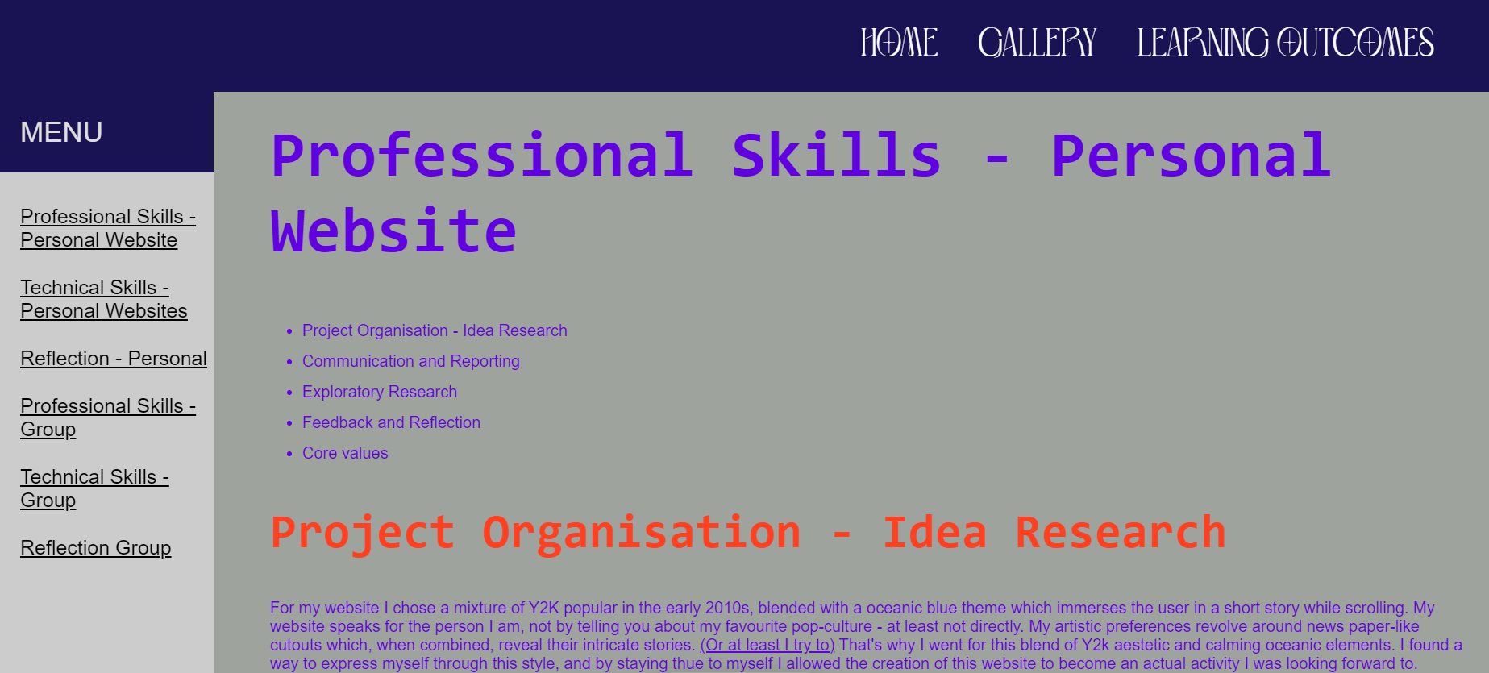

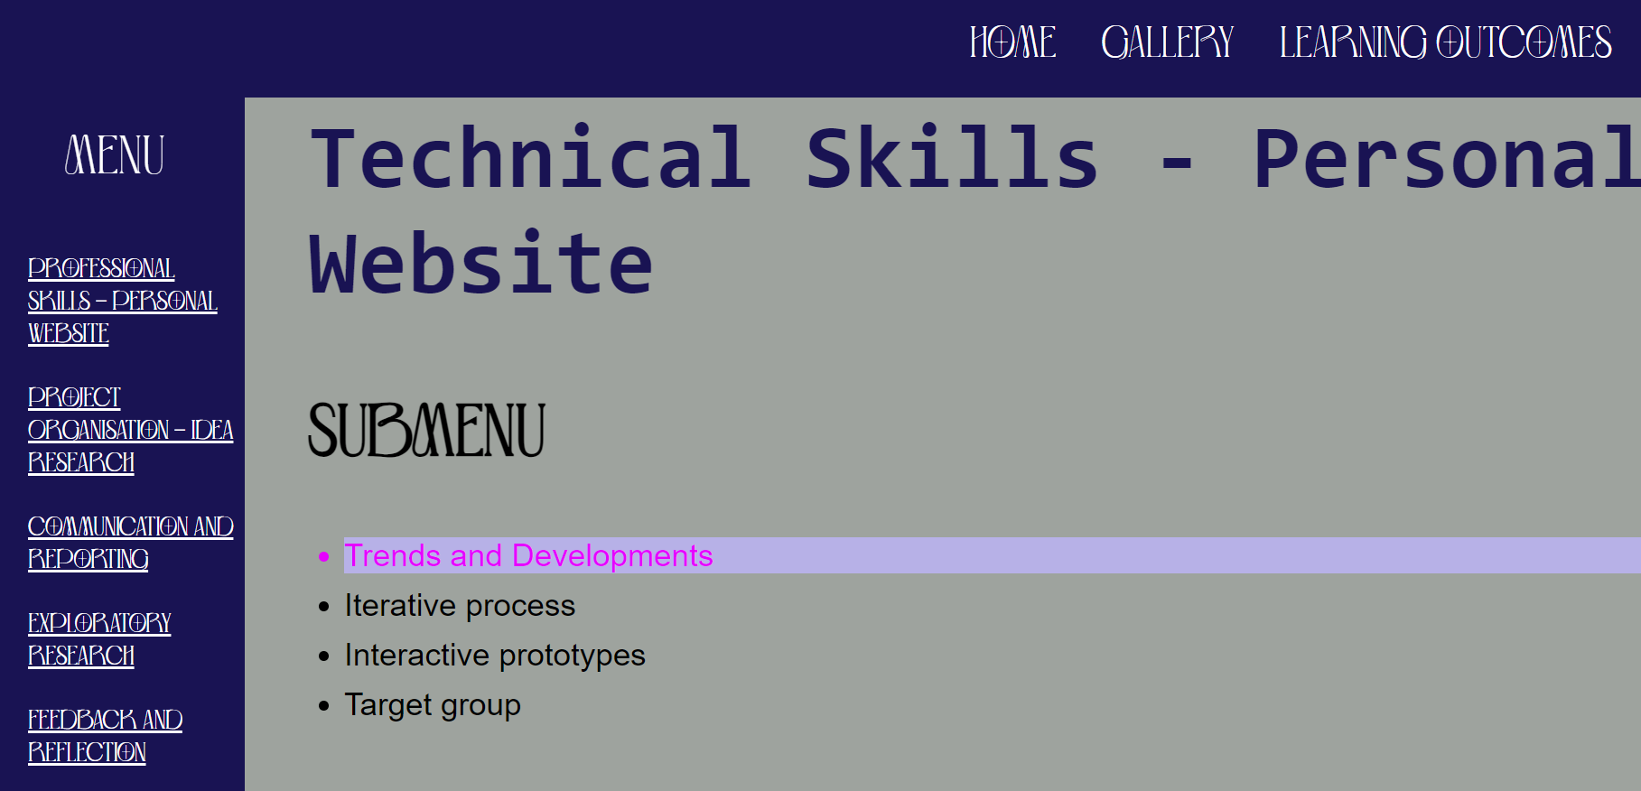

Don’t feela s this one is as clear so I adjusted it differently combining the other outcomes which were making the side Menu just a mess.

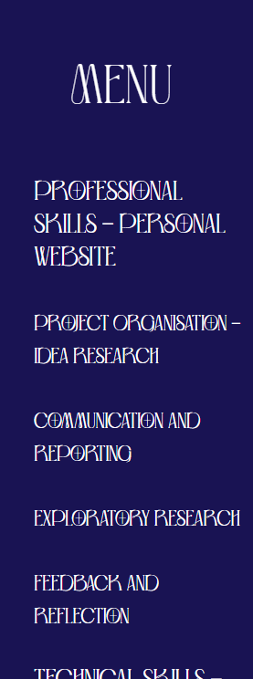

Changing the layout by moving the submenu inside the side menu for clarity.

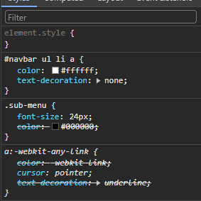

Adding color so the submenu sticks out but its getting overwritten by the color set in nav bar

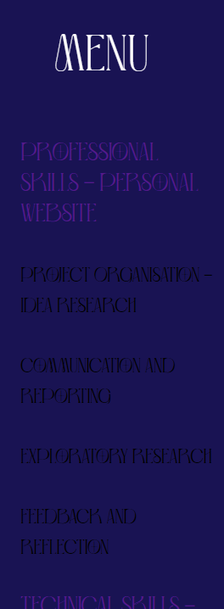

So I looked for a solution. At first I was thinking of moving color from #navbar ul li a {} to li only or specifying it but that was too messy so I looked for the problem I had with the overwriting of color I was experiencing and found out about the [!important property.](https://www.w3schools.com/css/css_important.asp)

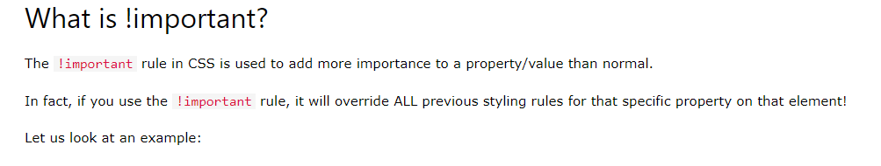

After carefully thinking through, talking with other colleagues, looking at their websites fro inspiration, I came up with the idea to make a slideshow menu out of the two main outcomes to make the layout way more clear.

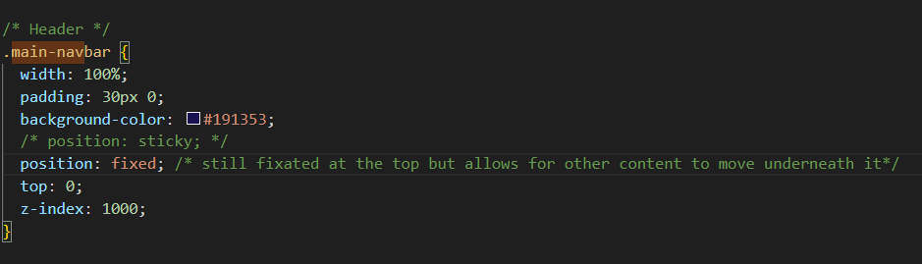

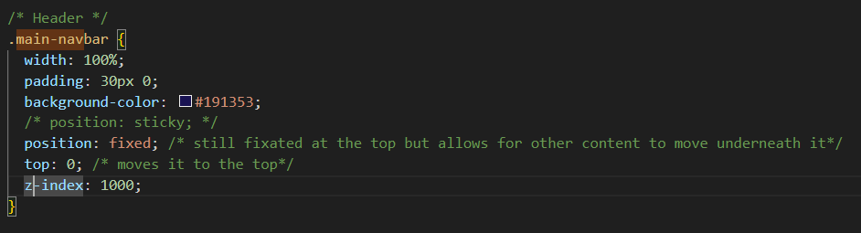

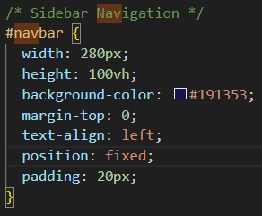

How I did it;

* **Fixed Positioning**: This correctly describes the technique used to keep both elements fixed relative to the viewport. This ensures they stay in their respective positions even when the user scrolls the page.
* **Z-index Removal**: If you removed the z-index or set it to a lower value on .navbar, this action allows .navbar to appear visually in front of .main-navbar. This is because elements without a z-index specified or with a lower value appear behind elements with a higher z-index.

### Clarification on Z-index:

* **Higher vs. Lower Z-index**: Elements with a higher z-index value appear in front of elements with a lower or no z-index specified. By setting .navbar to have a lower z-index or none, it allows it to naturally appear in front of .main-navbar, which typically would have a higher z-index if needed.

Refining the code, I positioned both .navbar and .main-navbar using position: fixed;, ensuring .main-navbar remains anchored at the top of the viewport. By fine-tuning their positioning and z-index values, I successfully achieved the desired layout where .navbar is placed above .main-navbar. This approach guarantees a consistent and functional design across various screen sizes and devices. I tailored the z-index values to align with my layout requirements and visual hierarchy, ensuring clear navigation accessibility.

Idea of slideshow

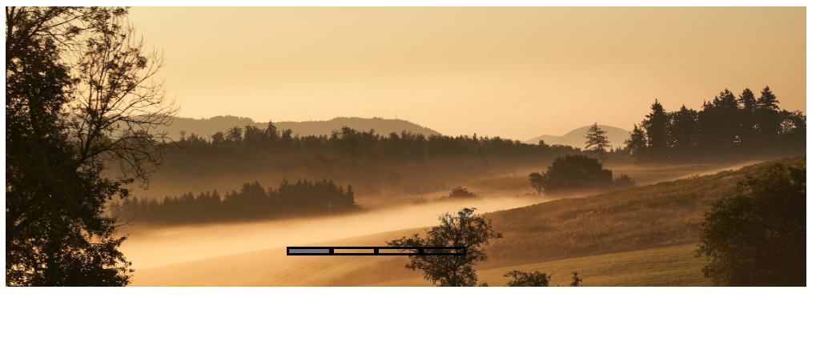

The shit I did witht the slideshow

Show how ive tweaked it explain how ive broke it

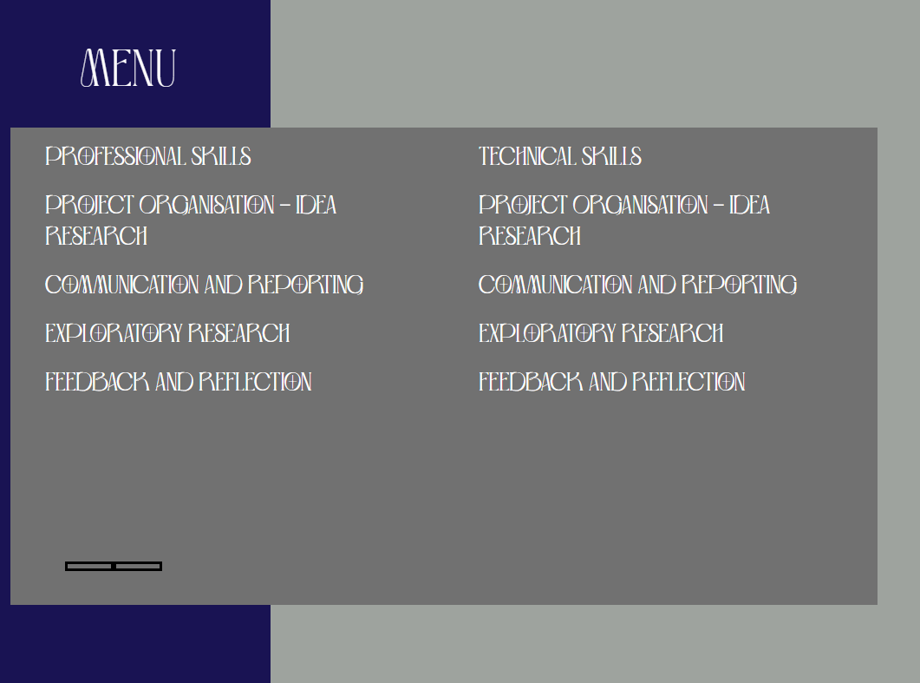

FIGMA PITCH

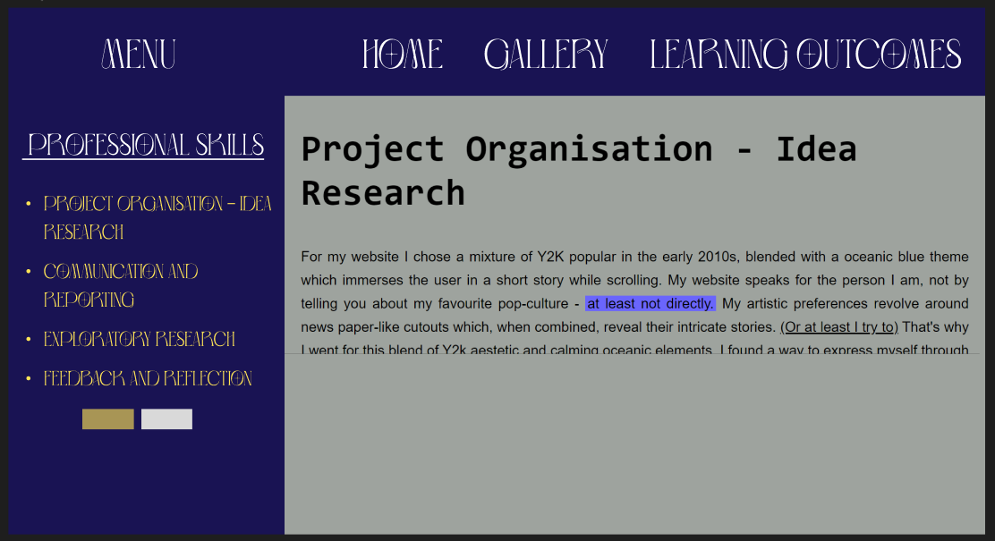

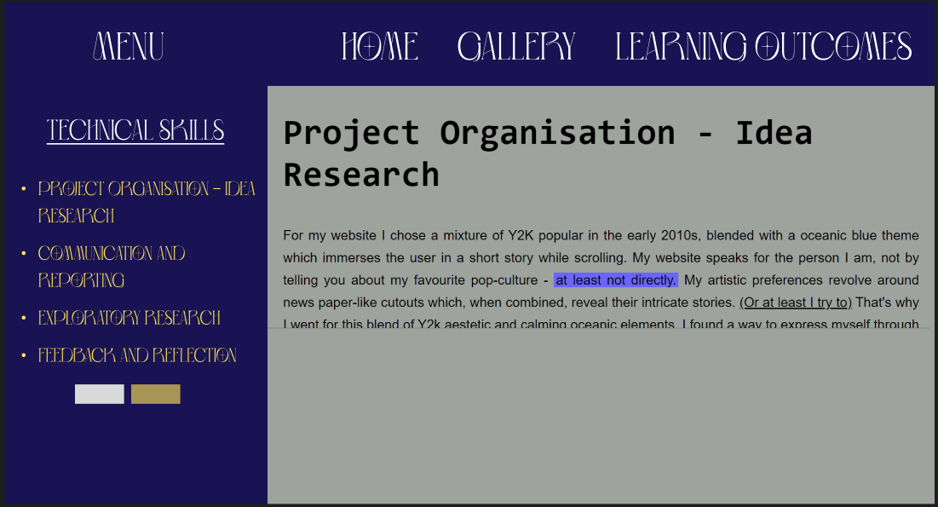

First I put navbar in front of main menu by adjusting z index of both ones

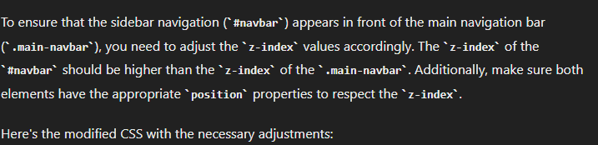

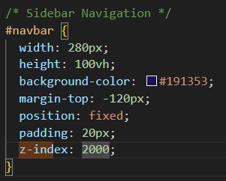

Explain how iv been struggling with the realization fo my idea of a slideshow and ive done my research by looking at other types of slideshows, and came to the conclusion of trying basic JavaScript to create a more [reliable tabs sldieshow.](https://mui.com/material-ui/react-tabs/)

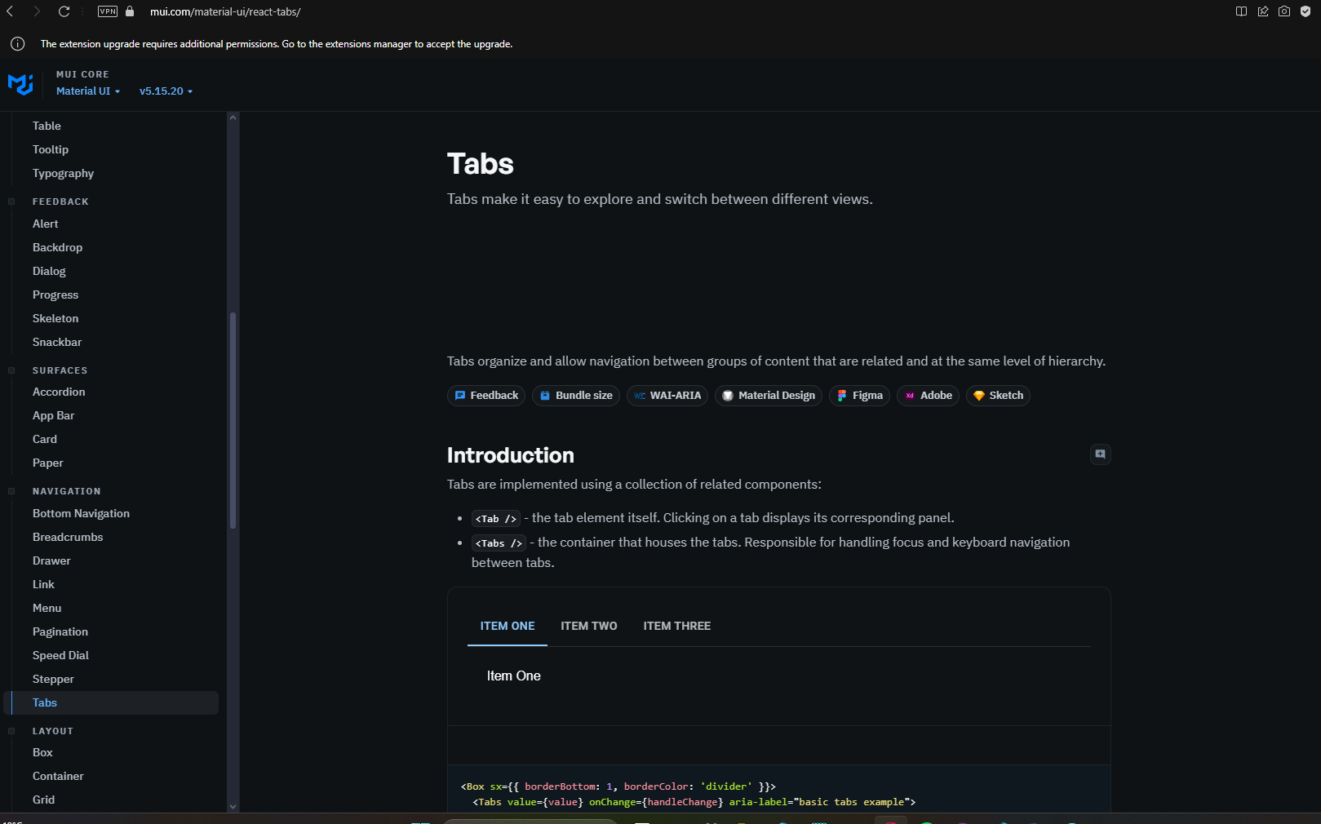

Final result:

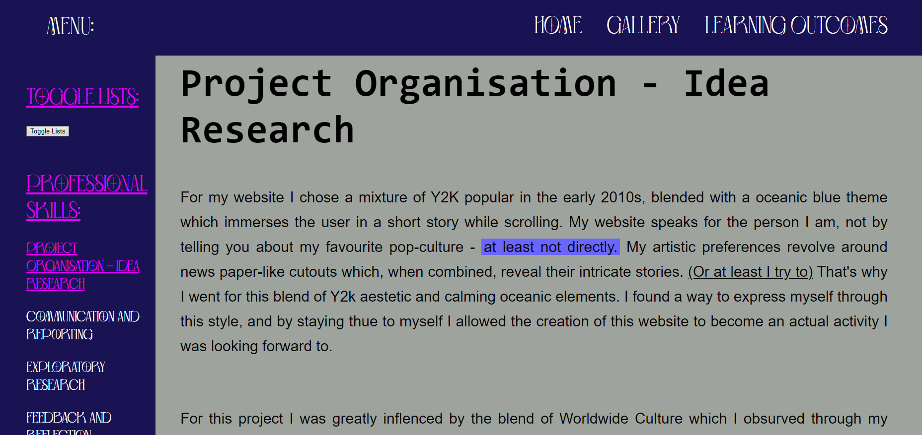

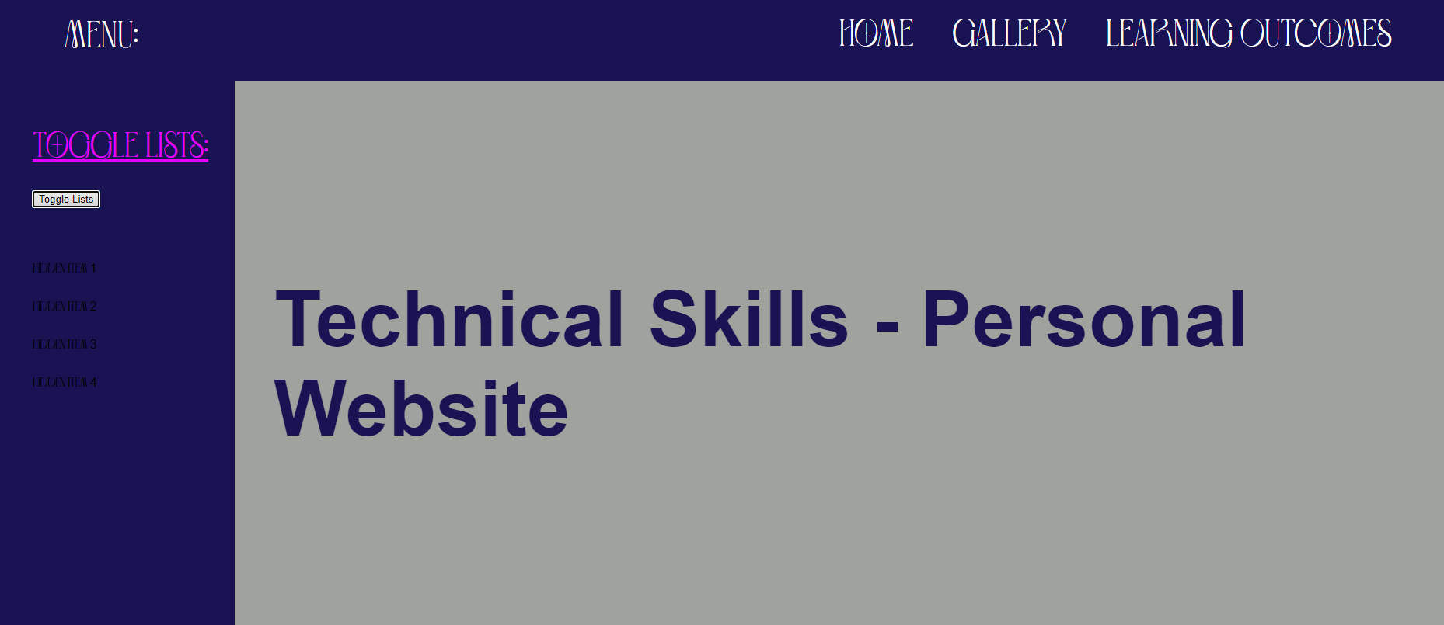

It works by clicking the button which switches the menus by hiding the one the user was on previously.

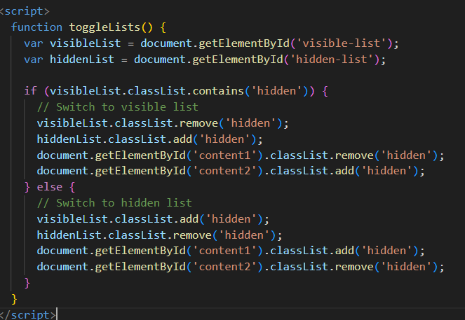

I asked Chat GPT for clarity, after it helped me create this function:

In summary, how this function works is by having two sets of content (#content1 and #content2) when the toggle button is clicked, it provides seemless navigation through the side menu of my webpage, bringing the clarity needed for me and the teachers I received feedback from.

This is how I resolved the issue with the clattery that my side menu, and overall navigation on my webpage, adding #content1 and #content2 to fit on the page. - "Professional Skills" and "Technical Skills" sections., without changing the style of my page – an option I tried considering but was unsatisfied with, because it was unique.

* The alternative approach I was considering:

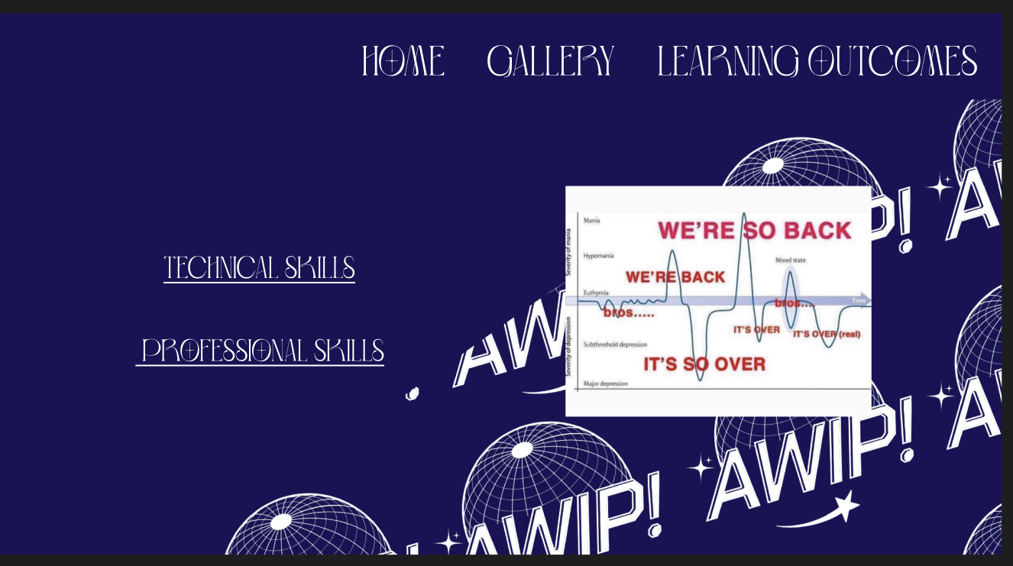

LATEST WEBPAGE VERSION:

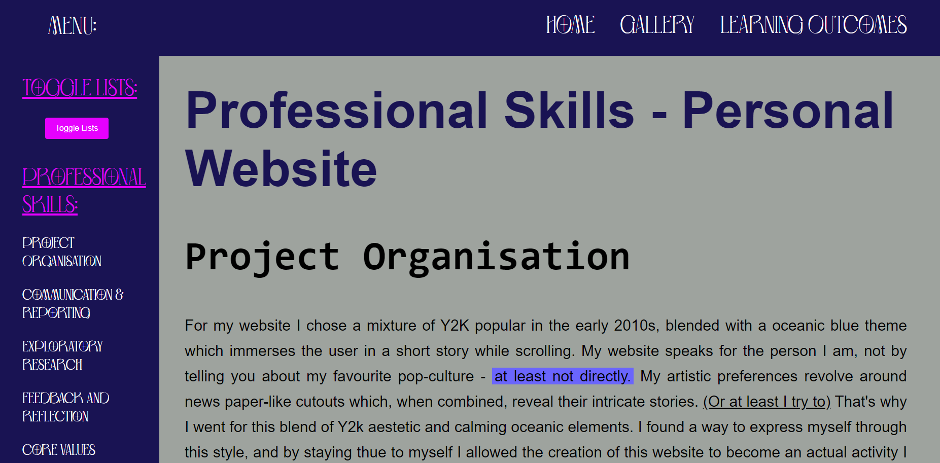

Now that I’ve added the outcomes for Professional skills and linked them in the sub menu all that is left for me is to fully document them, do the same for the Technical Skills, ask for feedback from teachers on the change, and finish the rest of the website.

BEFORE:

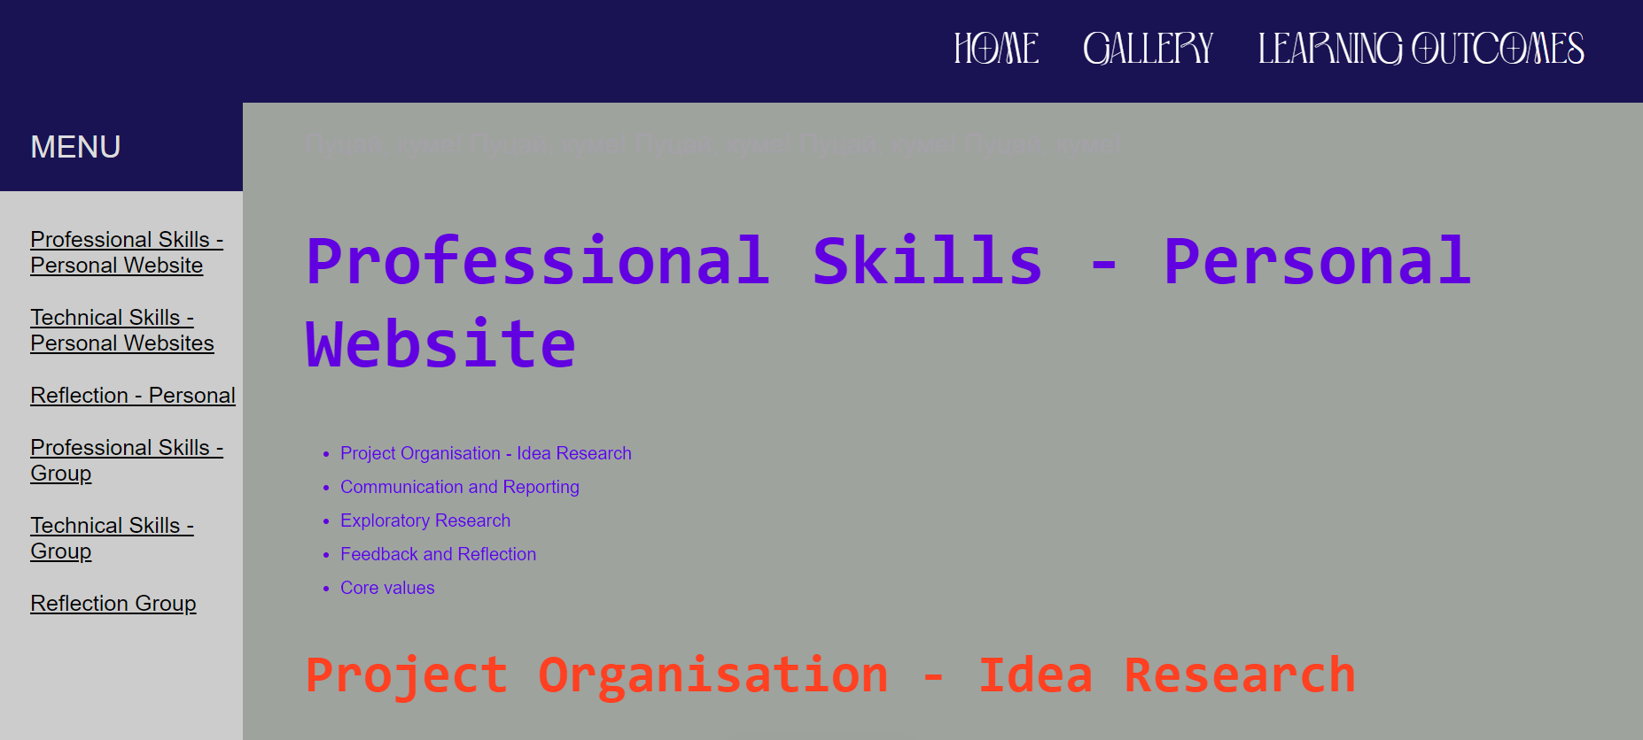

AFTER:

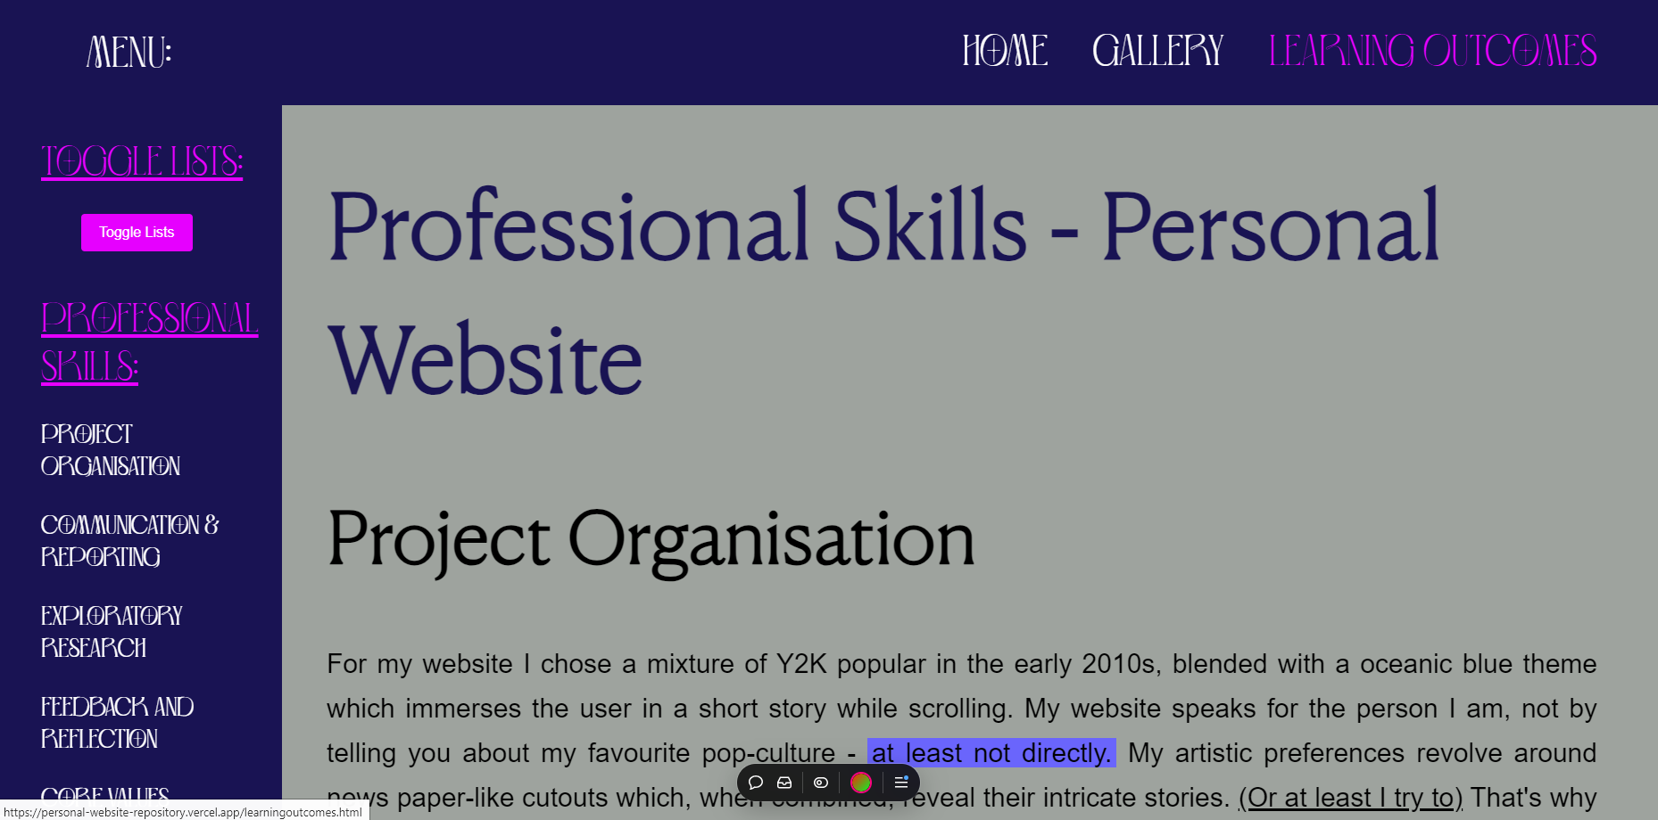

To do over the weebend:

Finish all the outcomes documentation both website and document

Finish main as well